UNITED STATES
SECURITIES AND EXCHANGE COMMISSION
Washington, D.C. 20549
SCHEDULE 14A
(RULE 14a-101)
INFORMATION REQUIRED IN PROXY STATEMENT
SCHEDULE 14A INFORMATION
Proxy Statement Pursuant to Section 14(a) of the
Securities Exchange Act of 1934
(Amendment No. )
Filed by the Registrant ☒ Filed by a Party other than the Registrant ☐
Check the appropriate box:
☐ |  | Preliminary Proxy Statement
☐ |  | Confidential, for Use of the Commission Only (as permitted by Rule 14a-6(e)(2))
☐ |  | Definitive Proxy Statement
☒ |  | Definitive Additional Materials
☐ |  | Soliciting Material under § 240.14a-12
LENSAR, Inc.
(Name of Registrant as Specified in its Charter)
(Name of Person(s) Filing Proxy Statement, if other than the Registrant)
Payment of Filing Fee (Check all boxes that apply):
☒ |  | No fee required.
☐ |  | Fee paid previously with preliminary materials.
☐ |  | Fee computed on table in exhibit required by Item 25(b) per Exchange Act Rules 14a-6(i)(1) and 0-11

Your Vote Counts!

LENSAR, INC.

2026 Annual Meeting
Vote by August 3, 2026
11:59 PM ET

LENSAR, INC.
2800 DISCOVERY DRIVE
SUITE 100
ORLANDO, FL 32826

T01128-P54663

You invested in LENSAR, INC. and it’s time to vote!
You have the right to vote on proposals being presented at the Annual Meeting. This is an important notice regarding the availability of proxy materials for the stockholder meeting to be held on August 4, 2026.

Get informed before you vote
View the Notice and Proxy Statement and Annual Report online at www.ProxyVote.com OR you can receive a free paper or email copy of the material(s) by requesting prior to July 21, 2026. If you would like to request a copy of the material(s) for this and/or
future stockholder meetings, you may (1) visit www.ProxyVote.com, (2) call 1-800-579-1639 or (3) send an email to sendmaterial@proxyvote.com. If sending an email, please include your control number (indicated below) in the subject line. Unless requested, you will not otherwise receive a paper or email copy. There is NO charge for requesting a copy.

For complete information and to vote, visit www.ProxyVote.com

Control #

Smartphone users
Point your camera here and vote without entering a control number

Vote Virtually at the Meeting*
Date: August 4, 2026
Time: 11:00 A.M. ET

Meeting to be held virtually at:
www.virtualshareholdermeeting.com/LNSR2026
Vote Prior to the Meeting:
Online: ProxyVote.com
By Mail: You can vote by mail by requesting a paper copy of the materials, which will include a proxy card.

*Please check the meeting materials for any special requirements for meeting attendance.

Vote at www.ProxyVote.com

THIS IS NOT A VOTABLE BALLOT
You cannot use this notice to vote these shares. This is only an overview of the proposals being presented at the upcoming stockholder meeting. You may view more complete proxy materials online at www.ProxyVote.com or request a paper copy (see reverse side). Please follow the instructions on the reverse side to access and review all of the important information contained in the proxy materials before you vote.

Board Recommends

Voting Items

1. Election of Class III Directors
For

Nominees:
01) Thomas B. Ellis
02) Richard L. Lindstrom, MD
03) William J. Link, PhD

2. Ratification of the appointment of PricewaterhouseCoopers LLP as LENSAR, Inc.’s independent registered public accounting firm for 2026
For

3. Approval, on an advisory (non-binding) basis, of the compensation of LENSAR, Inc.’s named executive officers
For

4. Approval, on an advisory (non-binding) basis, of the frequency of future advisory (non-binding) votes on the compensation of LENSAR, Inc.’s named executive officers
1

Year

NOTE: Such other business as may properly come before the Annual Meeting or any continuation, postponement or adjournment thereof.

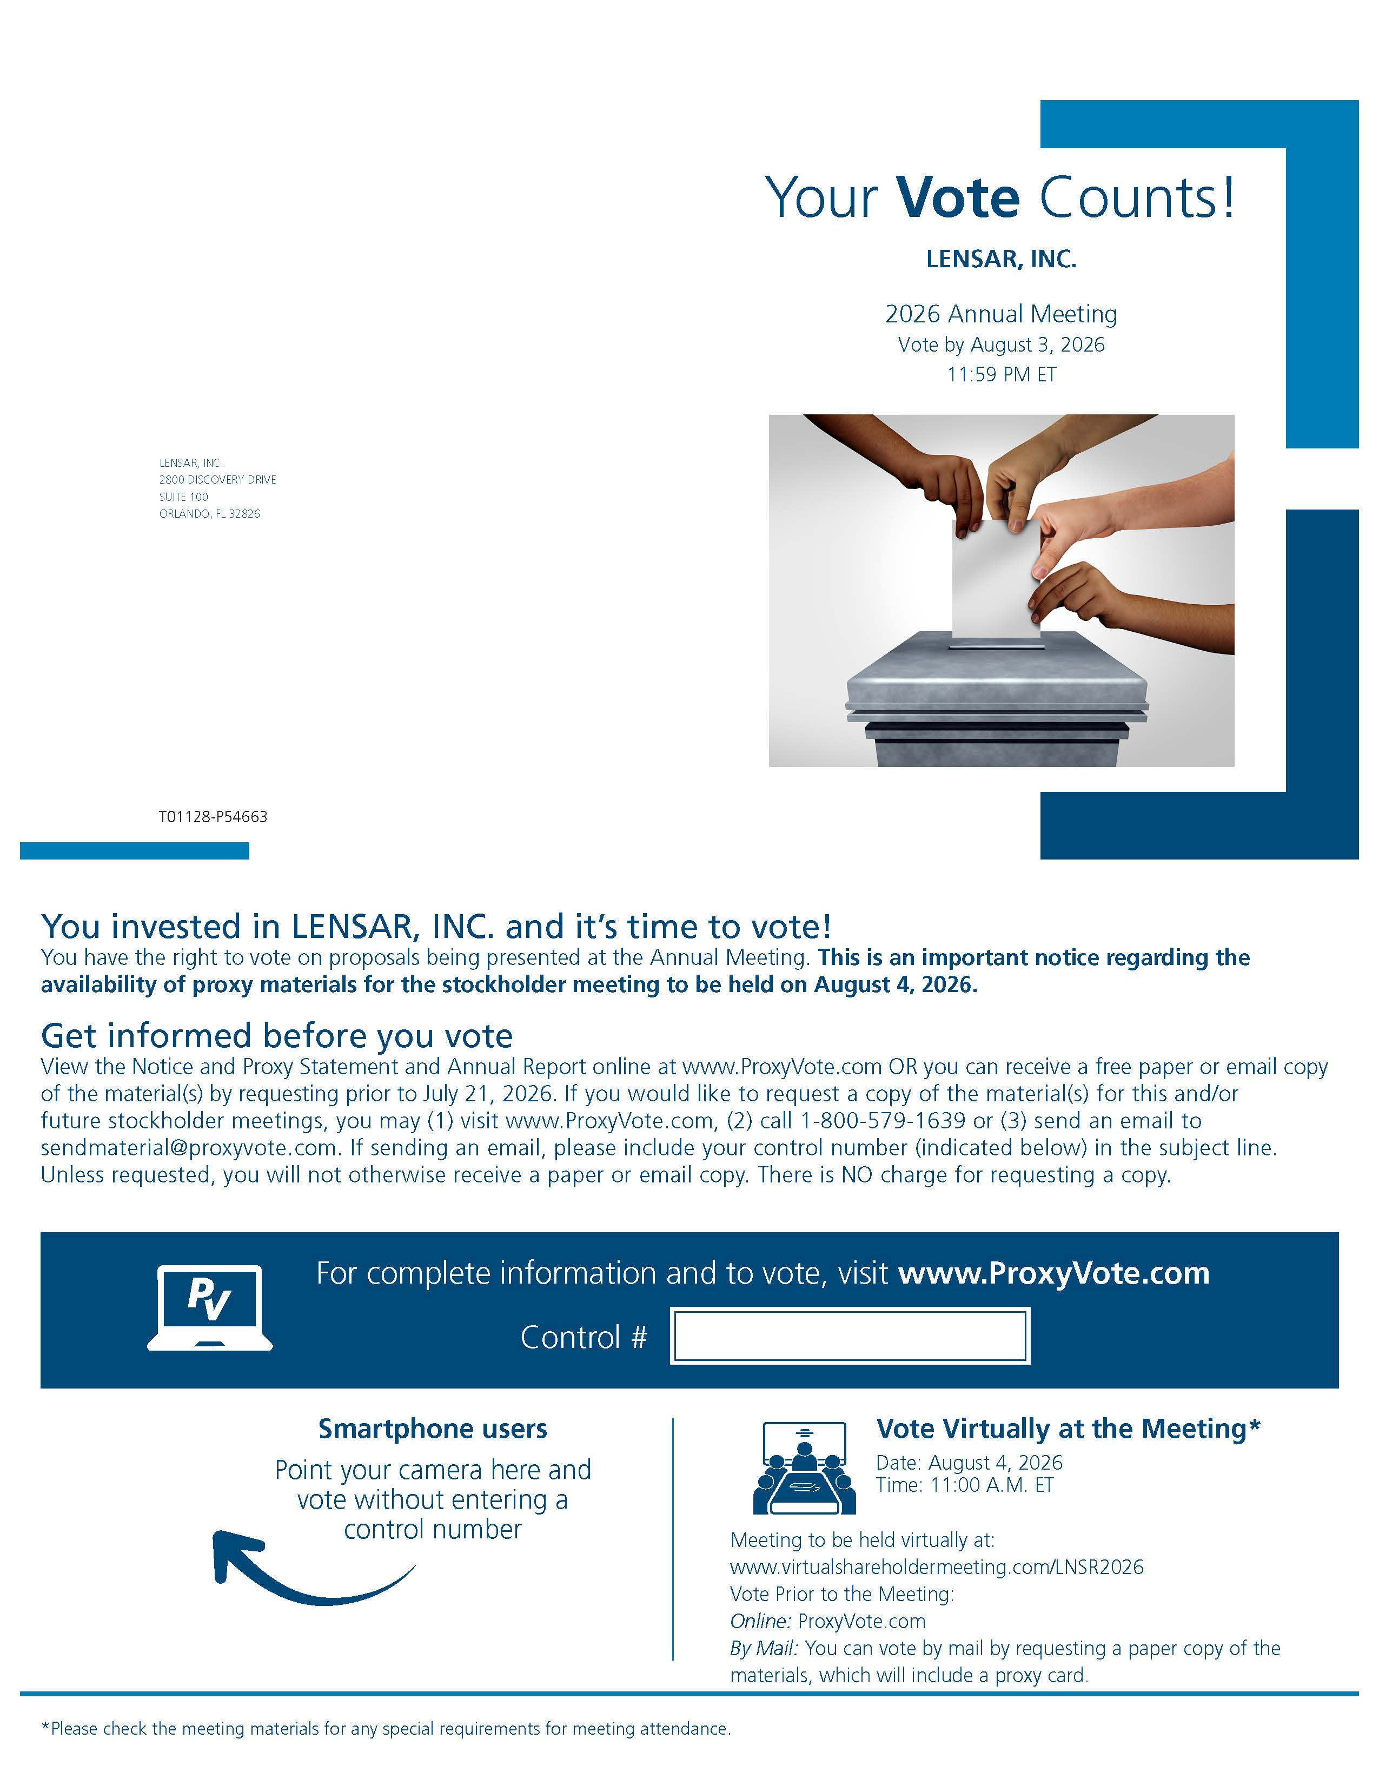

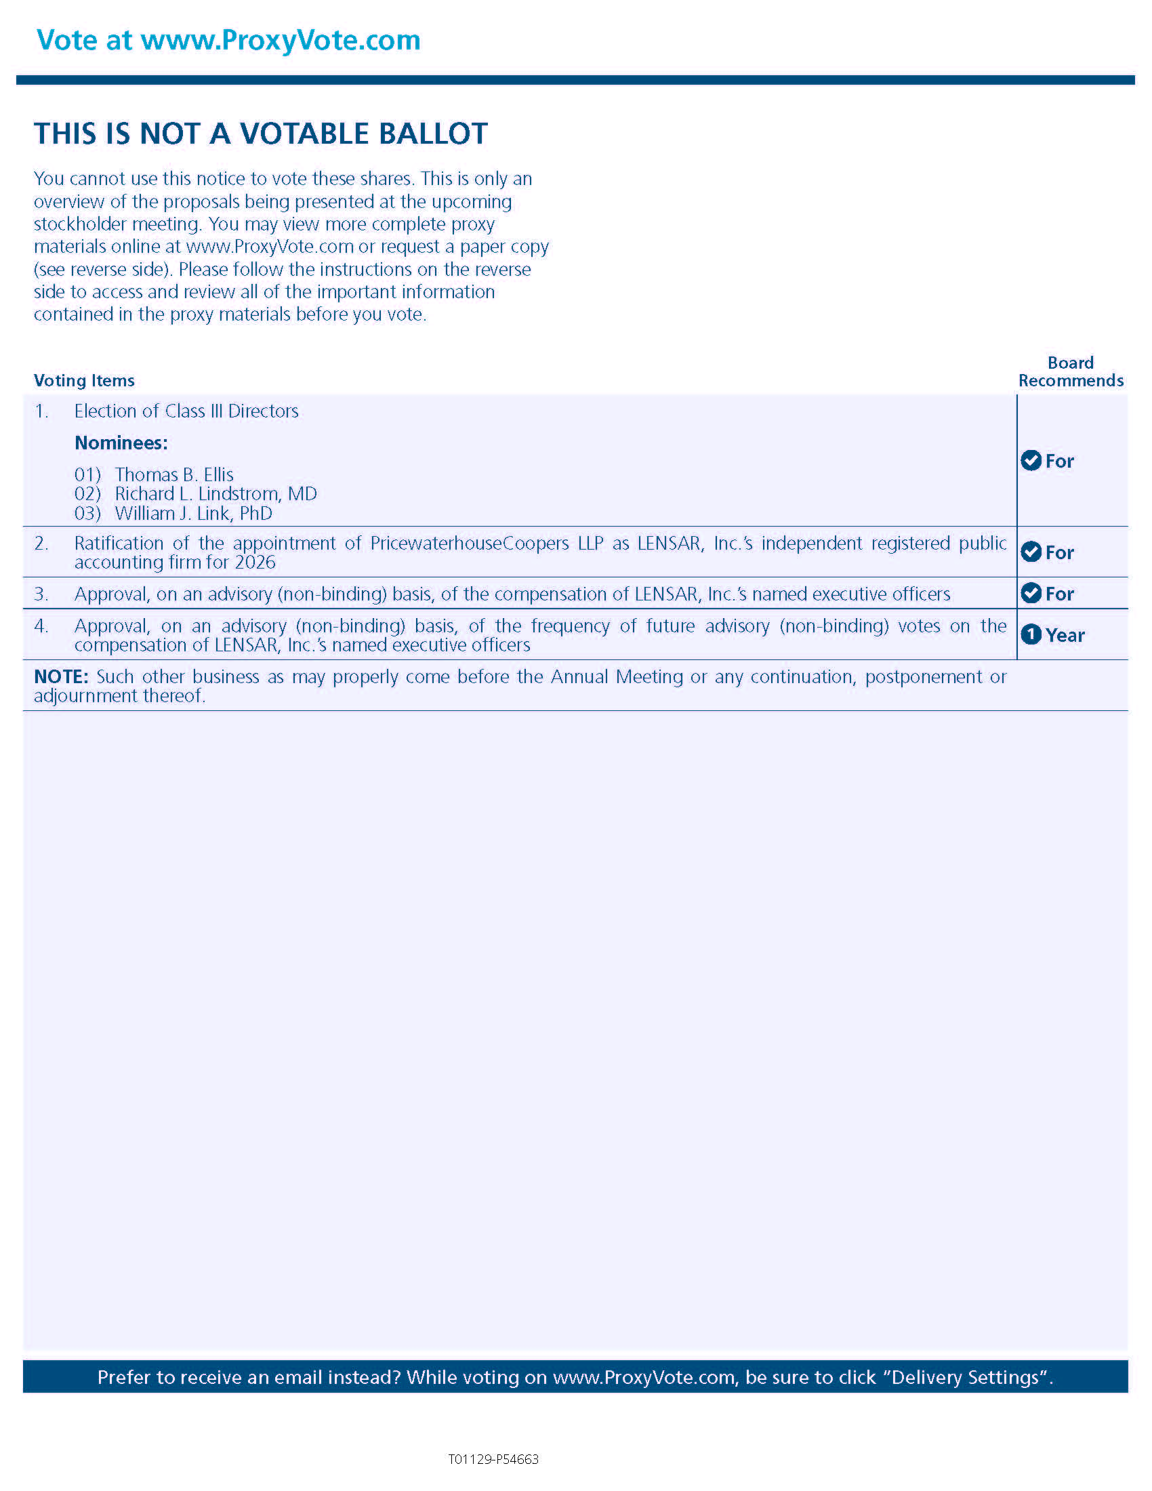

Prefer to receive an email instead? While voting on www.ProxyVote.com, be sure to click “Delivery Settings”.

T01129-P54663

